

**Fuseboard lifetime test report**

The purpose of this document is to present the methodology, execution and results of a lifetime test conducted on the Krakul’s developed fuseboard for DefSecIntel.

Client: DefSecIntel Solutions OÜ

Project: Kr-Df-01

Date: 2025-04-23

Krakul OÜ

Pärnu mnt 186, 11314

Tallinn, Estonia

[www.krakul.eu](http://www.krakul.eu)

[info@krakul.eu](mailto:info@krakul.eu)

Reg nr: 12458980

VAT nr: EE101631527

This report outlines the scope and objectives of the lifetime test, the test setup and conditions. The performance is evaluated and analysed which will contribute to the product’s validation and risk assessment. The report is shared inside a zip file which also contains raw logs and pictures/videos of the test environment and tests.

**Table of contents**

1 Acronyms 3

2 Introduction 3

3 Fuseboard Overview 3

4 Test procedure 4

4.1 Test environment 4

4.2 Physical load configuration 4

4.3 Testing script description 5

4.4 Fuseboard port software configuration 5

4.5 Test setup pictures 6

5 Results 8

5.1 Room temperature (~20 degrees) lifecycle test 8

5.1.1 Setup 8

5.1.2 Result 8

5.2 Low temperature (~-40 degrees) lifecycle test 8

5.2.1 Setup 8

5.2.2 Result 8

5.3 High temperature (~55 degrees) lifecycle test 9

5.3.1 Setup 9

5.3.2 Result 9

5.4 Extra High temperature (85 degrees) lifecycle test 9

5.4.1 Setup 9

5.4.2 Result 9

5.5 Overload test 9

5.5.1 Setup 9

5.5.2 Result 10

5.6 Fuse blow test 10

5.6.1 Setup 10

5.6.2 Result 10

6 Summary 12

# Acronyms

|  |  |
| --- | --- |
| Acronym | Meaning |
| DUT | Device under test |
|  |  |
|  |  |
|  |  |
|  |  |

# Introduction

As the primary power supply and monitor unit of the system, validating the long-term reliability of the fuseboard is critical. Lifetime testing, also known as endurance, durability or long-term testing is a key part of product development and qualification process. This involves operating the device under predefined conditions for an extended period, or through accelerated aging simulation.

This report focuses on the lifetime test performed on DefSecIntel/s Fuseboard, which was developed by Krakul with the purpose of managing and monitoring the system power. The device is expected to operate continuously in a large temperature range with different load properties.

The primary goal of the lifetime test is to evaluate the long-term operational stability of the fuseboard. This test will simulate the expected lifecycle of the device under specific conditions, validate the robustness of key components and provide data to predict the time to failure of the device.

This report documents the long-term test objectives, the procedure of the test and presents the results using logged data and observations during the test.

# Fuseboard Overview

The fuseboard, DUT, is a power distribution board developed to load switch and monitor the power outputs of an attached system. The device under test is Kr-DF-01 Fuseboard, hardware revision v1.0 and firmware version v1.0.0.0

The key components of the device are the load-switching relays, which are also considered as the highest-risk components when it comes to the device lifetime. The board is controlled by and STM32 MCU, which handles the communication and logic of the device.

The device is designed to be used as the load switch of a bigger electrical system, so the impact of this device-s lifetime defines the service life of a bigger system. Understanding its’ behaviour over time helps validate design assumptions and supports confident deployment in the targeted use.

# Test procedure

## Test environment

The test equipment and how it is connected can be seen in the pictures supplied with this report document. The DUT was placed in the climate chamber.

The lifetime test was conducted in four different temperature environments:

1. Room temperature ~20 degrees
2. Low temperature ~-40 degrees
3. High temperature ~55 degrees
4. Extra high temperature ~85 degreesStage 2: Cold temperature test environment. The DUT was placed in a climate chamber with an ambient temperature of -40 degrees Celsius.

## Physical load configuration

|  |  |  |  |  |
| --- | --- | --- | --- | --- |
| Port number | Physical fuse | Load schematic | Load description | Calc. load |
| 1 | 5 A | No load | - | - |
| 2 | 5 A | No load | - | - |
| 3 | - | No load |  | - |
| 4 | 5 A | Electronic load, set to 1 A |  | 1 A |
| 5 | 10 A |  | Inductive load. Simulated with a long cable in a spool | 2.38 A |
| 6 | 10 A |  | Normal resistive load. | 2.38 A |
| 7 | 15 A |  | High resistive load. | 14.875 A |
| 8 | 15 A |  | High Capacitive load | 14.875 A |

## Testing script description

The testing script sequence was identical in stages 2-4. In the other stages the sleep interval of the test was adjusted, as well as port configuration.

1. Open connection to fuseboard
2. Configure fuseboard Ports (see fuseboard port software configuration)
3. Enable ports 0-7 with 0.2 second interval
4. Read port statuses
5. Disable ports 0-7 with 0.2 second interval
6. Read port Statuses
7. Sleep 10 seconds

## Fuseboard port software configuration

|  |  |  |  |  |  |
| --- | --- | --- | --- | --- | --- |
| Port number | Startup state (delay) | Forward current limit (mA) | Current limit activation time | Current limit operation time | Recovery mode |
| 0 | 0 (0) | 5000 | 200 | 200 | 0 |
| 1 | 0 (0) | 5000 | 200 | 200 | 0 |
| 2 | 0 (0) | 5000 | 200 | 200 | 0 |
| 3 | 0 (0) | 5000 | 200 | 200 | 0 |
| 4 | 0 (0) | 10000 | 200 | 200 | 0 |
| 5 | 0 (0) | 10000 | 200 | 200 | 0 |
| 6 | 0 (0) | 15000 | 200 | 200 | 0 |
| 7 | 0 (0) | 15000 | 200 | 200 | 0 |

## Test setup pictures

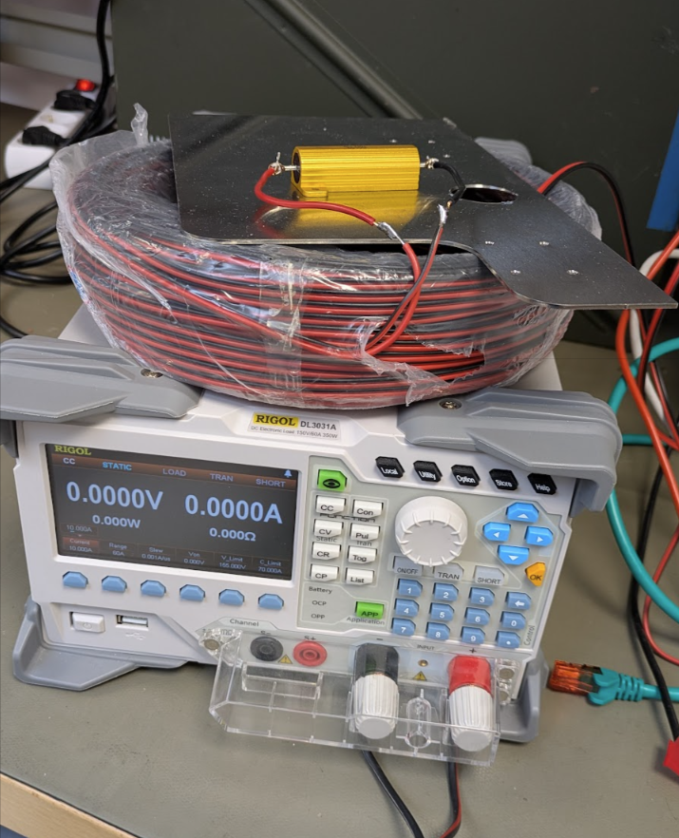

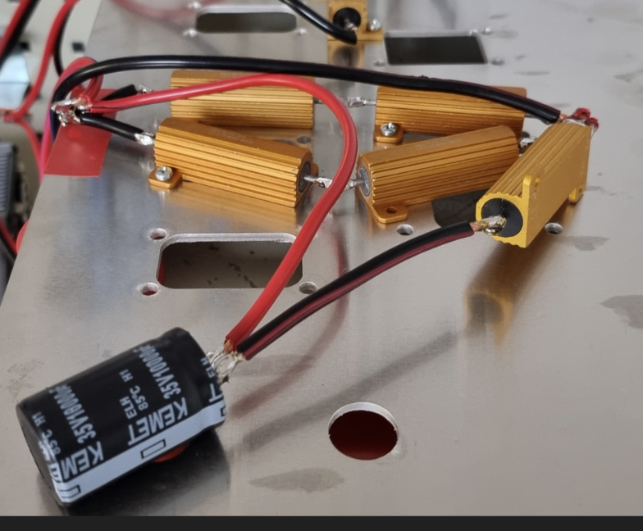

# Results

## Room temperature (~20 degrees) lifecycle test

### Setup

Data and logs are in files named fb_lt_test_15_04_2025-16_29

Test setup is exactly as explained in paragraph 5.

### Result

The test ran for ~1000 cycles.

The DUT switched all relays correctly throughout the test. After the test the DUT works correctly.

## Low temperature (~-40 degrees) lifecycle test

### Setup

Data and logs are in files named fb_lt_test_16_04_2025-10_48

Test setup is exactly as explained in paragraph 5.

### Result

The test ran for ~1000 cycles.

The DUT switched all relays correctly throughout the test. After the test the DUT works correctly.

At one point we saw that the low degrees have caused a little snow build-up on the fuseboard and wiring. This did not cause any damage to the board or alter the test.

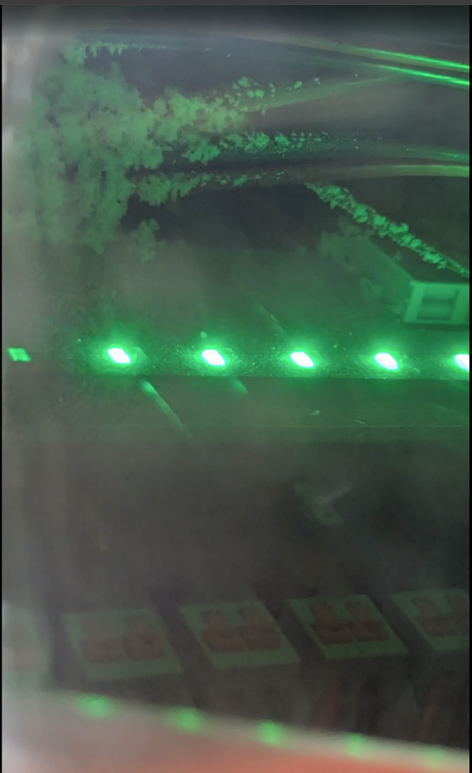

## High temperature (~55 degrees) lifecycle test

### Setup

Data and logs are in files named fb_lt_test_17_04_2025-11_11

Test setup is exactly as explained in paragraph 5.

### Result

The test ran for ~1000 cycles.

The DUT switched all relays correctly throughout the test. After the test the DUT works correctly.

## Extra High temperature (85 degrees) lifecycle test

### Setup

Data and logs are in files named fb_lt_test_21_04_2025-14_51

Test setup is exactly as explained in paragraph 5 except that there was no electronic load attached to port 4.

### Result

The test ran for **8652** cycles. We switched the test off after ~45 hours of continuous running.

The DUT switched all relays correctly throughout the test. After the test the DUT works correctly.

Example measured currents per port when relay was opened were as follows:

1. 0 mA
2. 0 mA
3. 0 mA
4. 0 mA
5. 1760 mA
6. 2380 mA
7. 14550 mA
8. 14520 mA

## Overload test

### Setup

We test on port 7. The usual circuit draws ~14.5A. We connected electronic load in parallel and continuously add more current draw per test. Port 7 is configured to forward_current_limit 15A and current_limit_activation_time_ms as 200.

Attached fuse is 15 A. This means both the fuseboard port 7 limit and fuse have the same 15A limit values.

Test done with fuseboard in high temperature aka 85 degree environment.

We are testing if fuseboard survives different current draw overload levels.

We check for 3 results

1. Does fuseboard port 7 current limit protection trigger
2. After lowering circuit draw back to 14.5A is fuseboard port 7 output OK
3. Is the fuse OK

### Result

We measured how long does the current limit protection take to trigger on one of the tests by video recording.

1. Current drawn raised at 12:50:16.485
2. Fuse blew (by sound of fuse blowing in the video) at 12:50:17.456
3. Time for fuse blown is 17.456 - 16.485 = **0.971 seconds.**
4. This time includes
   1. configured current_limit_activation_time_ms (200 ms)
   2. Time for fuseboard to switch relay off
   3. Time for relay to switch off

Here are the results of different current draw tests:

1. +1 A aka 15.5A - current limit protection triggered, output OK, fuse OK
2. +3 A aka 17.5A - current limit protection triggered, output OK, fuse OK
3. +5 A aka 19.5A - current limit protection triggered, output OK, fuse OK
4. +8 A aka 22.5A - current limit protection triggered, output OK, fuse OK
5. +10 A aka 24.5A - current limit protection triggered, output OK, fuse OK
6. +12 A aka 26.5A - current limit protection triggered, output OK, fuse OK
7. +14 A aka 28.5A - current limit protection triggered, output OK, fuse OK

The electronic load we use does not support drawing more current so we must stop the test here.

## Fuse blow test

### Setup

We test on port 7. The usual circuit current draw is 14.5 A. We set port 7 forward_current_limit to 25A. We have an electronic load attached to the circuit that we can activate to raise circuit current draw to 24.5A.

Attached fuse is 15 A.

Test done with fuseboard in high temperature aka 85 degrees environment.

We are testing that the fuse blows in this configuration and how quickly it does.

### Result

We measured time from raising current draw to 24.5A to the moment the fuse blew by a video recording.

1. Current drawn raised at 13:08:19.107
2. Fuse blew (by sound of fuse blowing in the video) at 13:08:22.755
3. Time for fuse blown is 22.755 - 19.107 = **3.648 seconds**.
4. Fuseboard detected that fuse is broken, shows red LED.

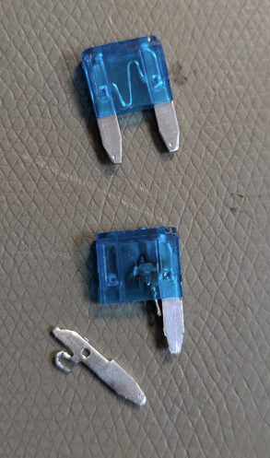

# Summary

The tests described above give confidence of the longevity and robustness of the Fuse Board v1.

Device was operated multiple cycles at temperature extremes with different loads without problems. Inductive loads are hard for relays at output turn-off and demonstrate the correct operation of flyback diode. Capacitive loads are hard at turn-on and demonstrate the inrush current tolerance of the output. Switching the output with maximum load for total of over 10 000 times shows that the relay does not operate on its limit and will provide adequate lifetime.

Overload tests demonstrates that relays can cut the current flow even if designed maximum rating is exceeded almost twofold. This demonstrates that the additional snubber circuits and relays with higher current ratings compared to Fuse Board v0 have been successful modifications.